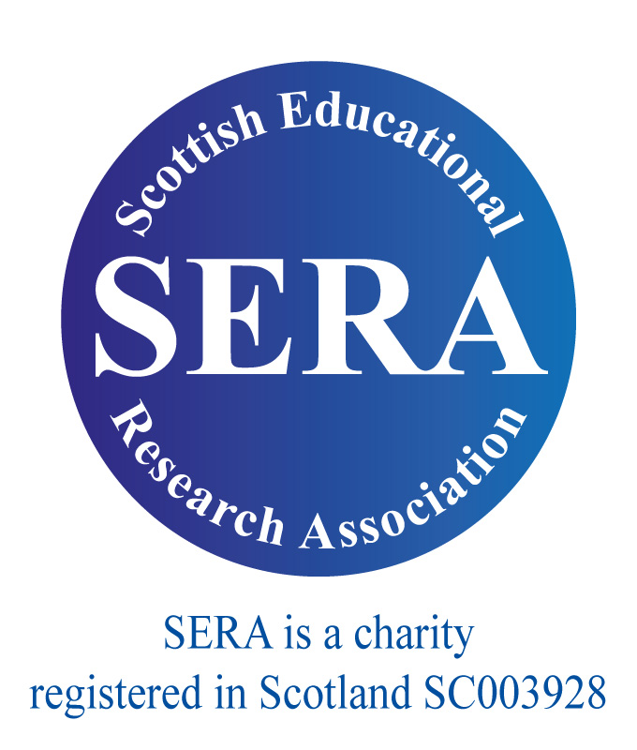 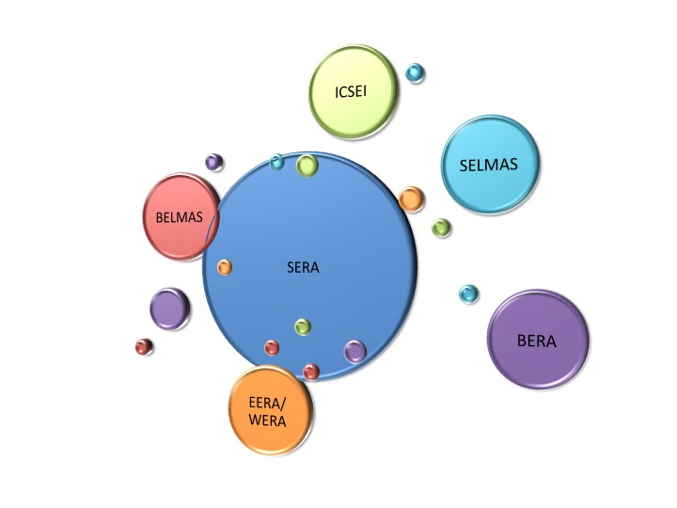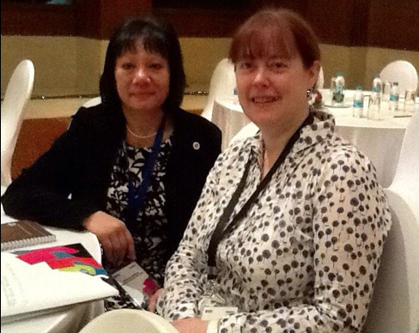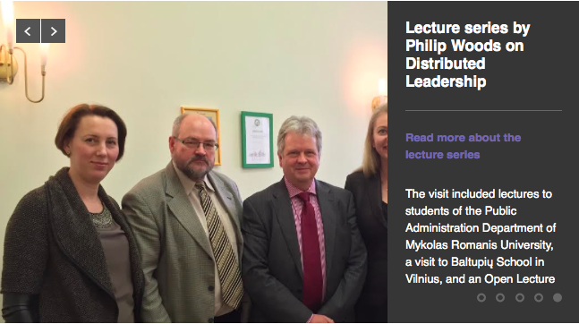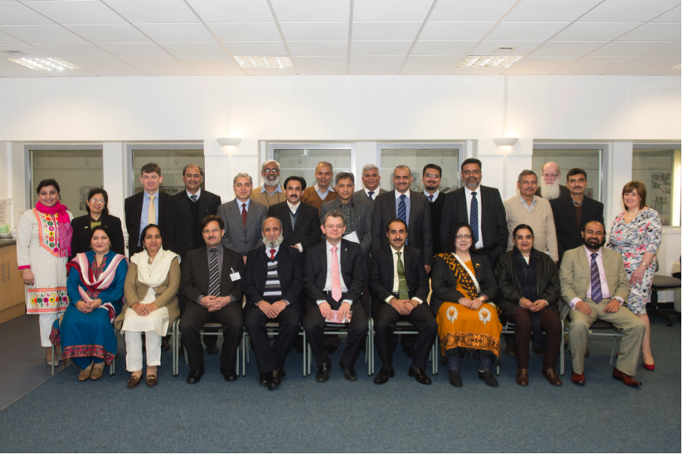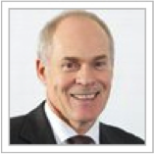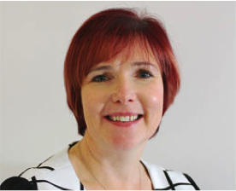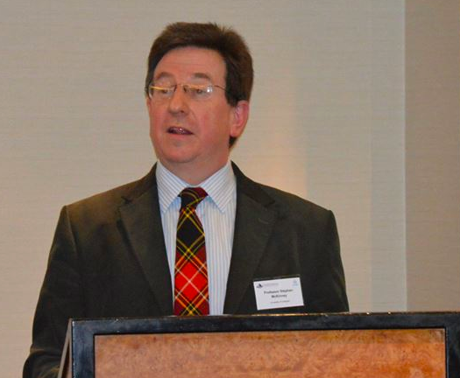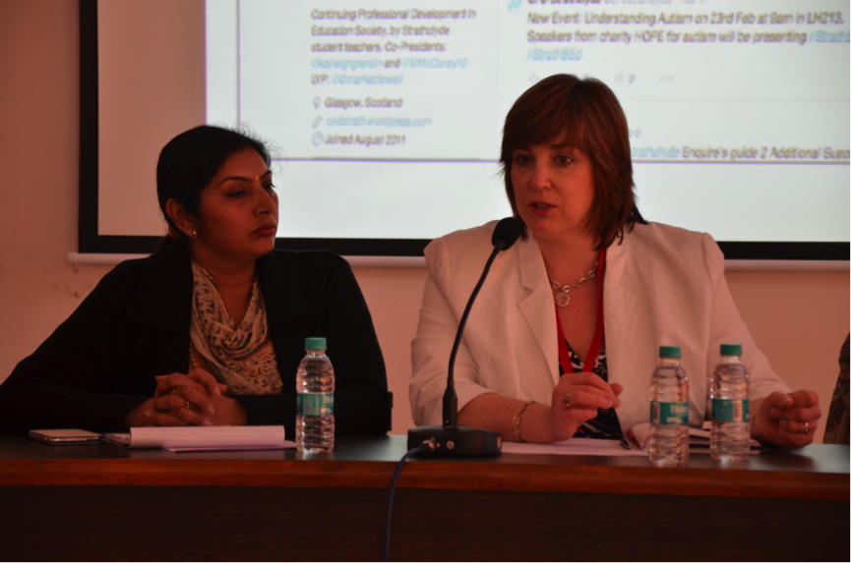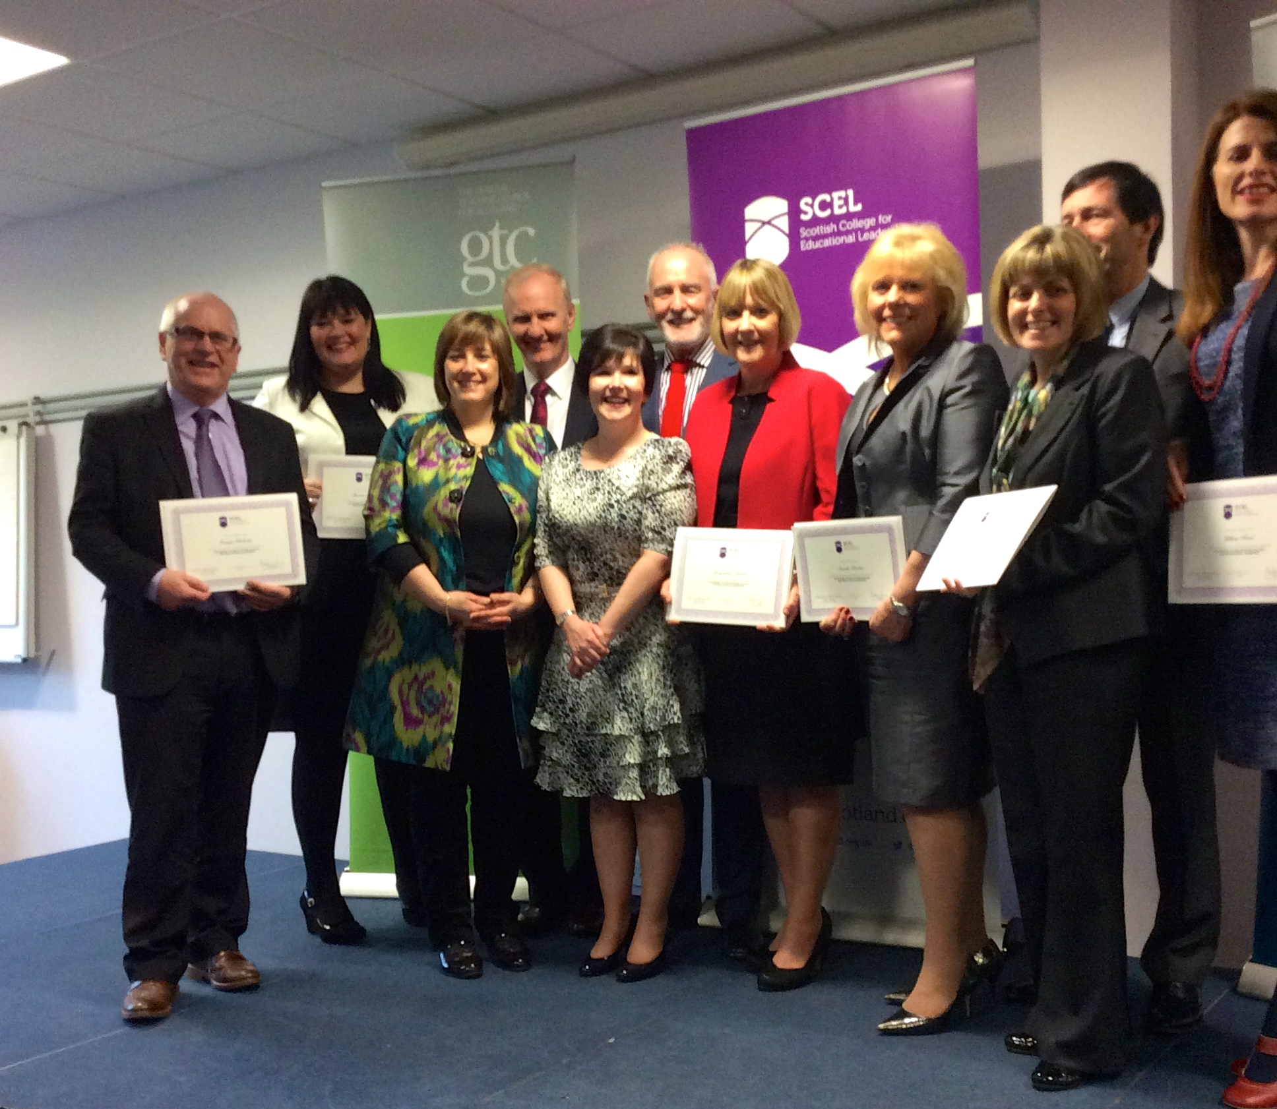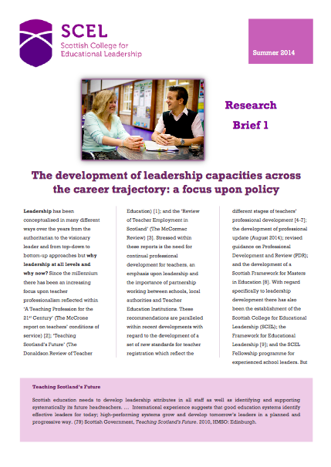

The network is open to both SERA and non-SERA members

Key Questions

**How can the new network influence the current leadership agenda in Scotland and beyond?**

**How can the new network promote research within the field of leadership to inform future understandings of leadership and leadership development within Scotland and beyond?**

spring 2015

**INSIDE THIS ISSUE**

1. **The focus of the network**
2. **Summary report of the inaugural meeting of the network**
3. **Planned events for the year**
4. **Recent publications, events & conference presentations**
5. **Other information and business**

Welcome to the first newsletter of the SERA Leadership in Scottish Education Network [LiSEN]. It was with great pleasure that Dr Margery McMahon, University of Glasgow, and myself, Dr Joan Mowat, University of Strathclyde, held the inaugural meeting of the network at the SERA Conference at the University of Edinburgh in Nov 2014. What was particularly pleasing was that we had representation from beyond Scotland and from key national organisations, such as Education Scotland. The session was devoted to discussion of a set of key questions (see side panels). The responses have been analysed and placed on the [SERA website](http://www.sera.ac.uk/networks/leadership/) and are summarised on page 3 of this newsletter.

# SERA Leadership in Scottish Education Network [LiSEN]

Newsletter 1

# The FOCUS of the Network

Key Questions

**How can the new network be promoted in Scotland and beyond? – By whom?**

**What other networks/associations/bodies should the network connect with? – What is the potential relationship with SCEL?**

**What are the key themes/issues that the network should engage with in its first year?**

**What vision would you have of the network in five years time? What would it have achieved? With what would it be engaged and with whom?**

**What suggestions do you have for the initial network events?**

The primacy of leadership in effecting change and improving outcomes for young people is seen in ongoing investment in building leadership capacity and capability across education systems, including Scotland. While leadership challenges and solutions are context specific, approaches to leadership development reflect global trends. Given the scale and speed of systemic change in education, the place and role of research in informing such approaches and supporting the development of leaders can be often be partial or *post factum*. This new SERA network will provide a forum to articulate and discuss leadership and leader learning and development; to connect academics, researchers, practitioners and policy makers; and to interact nationally and internationally with cognate research associations.

Objectives For coming year

* To publicise the network and to extend membership of it
* To produce a paper for the formal launch of the network and to seek publication of it in Scottish Education Review
* To organise the official launch of the Leadership in Scottish Education Network
* To develop strategy and an action plan for the network
* To organise network events
* To build a network strand for the SERA Conference 2015
* To prepare a progress report for the SERA Executive and for the SERA AGM 2015

The Desired aims and focus of the network

The quest to develop a research-informed understanding of educational leadership development in Scotland is perceived as a long-term endeavor and one that extends beyond Scottish boundaries to the international context. There is a need to look not only outwards, but inwards, examining beliefs, values and assumptions upon which much policy and practice reside. Central to the endeavor is the need to champion critical and independent, high quality research, enabling researchers to stand back from the policy context objectively.

The network should concern itself with examining the distinctiveness of Scottish education, examining how ‘leadership for all’ is understood and practised across sectors, and examining leadership at both a systems and a more local level. It should seek to widen the constituency of those who play an active role in research into leadership and leader development within Scotland, internationally and locally, strengthening the linkages between practitioners and researchers, recognising that practitioners can be involved in research in many ways.

Key features in the approach to be adopted by the network

A highly collaborative, outward-looking, dynamic, authentic and inclusive approach is advocated, reaching out to public bodies, the educational community and the research community. Working together with the General Teaching Council for Scotland [GTCS], the Scottish College for Educational Leadership [SCEL] and Education Scotland to make research accessible and setting up initial scoping meetings to examine how we can work together are important steps in achieving this end.

Engagement with wider professional bodies and research communities

There is a wide range of learned and professional bodies with which the network could form relationships. However, it is important not only to focus upon potential linkages but the nature and purpose of the link. Fostering the development of doctoral students in the field is crucial to ensure high quality research in the future. Collaborative ventures with public bodies could be highly beneficial in raising the profile of the network. Forming linkages with the newly developed SCEL Fellowship scheme would enable researchers to engage with highly experienced practitioners. Engaging with social and electronic media could potentially widen the network and publicise its work.

# Key Messages from discussion at inaugural SERA LiSEN meeting

Moray House School of Education

Dr Rowena Arshad, Head of Moray House School of Education, and Dr Deirdre Torrance in Delhi, India

Gender perspectives on leadership: A message from india

Mid-February, Dr Rowena Arshad and Dr Deirdre Torrance of the Moray House School of Education, University of Edinburgh, presented at two key events in Delhi, India. The first was the British Council Global Education Dialogue on Women and Leadership, ‘*The Absent Revolution.*’ The second was an international colloquium that they co-led with colleagues at the National University for Educational Administration and Planning [NUEPA], exploring *'Women Leadership in School Education.'* During the two-day NUEPA and UoE international colloquium, perspectives of women in school leadership roles in India and Scotland were shared. Three concrete proposals for joint action were agreed at the final session: a Massive Open Online Course (MOOC), a joint research proposal, and an edited collection of relevant papers on women and school leadership.

At the beginning of the British Council event, Jude Kelly, of the Southbank Centre in London challenged participants to consider, “Are we being too docile when it comes to issues of gender equality?” Jude reminded the audience that there was not a single country in the world where women did not have subordinate status to men. Professor Louise Morley, University of Sussex, asked the audience to reflect on why it is that, “Where there is power, women are absent?” Over the two days, a variety of perspectives were shared from a wide range of different country contexts covering most of South and also East Asia. Regardless of location in the world, one thing that unites us is the comparatively few women represented in leadership roles within higher education. This, despite the often much more equal proportion of women represented in undergraduate, postgraduate and PhD admissions.

Many of the conference sessions explored possible reasons for this. A comparatively low proportion of women go forward for research roles (rather than teaching roles), restricting future opportunities and limiting access to leadership positions. Specific issues relating to women's access to senior leadership positions in South Asia countries include restrictions on mobility, impacting upon employment opportunities, opportunities to attend conferences and the networking and opportunities arising from such, thus impacting negatively upon their academic reputations.

Internationally, the need to identify and establish strategies to redress the gender-gap were also explored throughout the two-day conference. Some recurring themes included: the benefits of mentoring; the importance of female role models; the need for established women encouraging and enabling less established women; guarding against ‘exceptionalism’; and the need to establish robust data gathering systems. The question was posed, 'If universities were rated for their equality credentials, would the league tables and world rankings look different?' If greater transparency became a requirement, it would not be left to individual women to answer the question, "Are we being too docile when it comes to issues of gender equality?"

# Reporting on Events

Leadership development programme for senior university leaders from pakistan

The School of Education, University of Glasgow, recently hosted a week-long leadership development programme for 25 university leaders from Pakistan. The University was awarded the contract by the British Council to deliver the programme following competitive tendering. Drawing on expertise from across the university the programme included interactive workshops on Enhancing the Student Experience, Strategic Leadership and Organisational Development and Change. The programme also included visits to Edinburgh Napier University and University of Edinburgh. Cultural highlights included a visit to the National Piping Centre and Museum and to the Kelvingrove Art Gallery and Museum. The programme director and LiSEN co-convener Dr McMahon said ‘the programme was a great success and underlines the potential for Scottish universities to support capacity building in other education systems.’

European policy network on school leadership

Both the GTCS and SCEL have been working with the EPNoSL network which aims at improving policy and practice on school leadership in Europe. To this effect a collaborative network in which members co-construct, manage and share knowledge has been set up. Among the themes being addressed this year are:

* Autonomy
* Accountabiity
* Distributed Leadership
* Policy Response
* Educating School Leaders

The Network engages in a wide range of activities across 42 European-based institutions and the GTCS recently hosted one such event. Representatives from SCEL will be present at the forthcoming event on 28th/29th May in Crete. The [EPNoSL website](http://www.schoolleadership.eu) has a very useful School Leadership Toolkit to facilitate policy reflection and planning; hosts webinars and discussions; enables national forums in 21 languages; provides information about previous and forthcoming events and gives access to keynote presentations from such events, such as the presentation by Philip Woods on distributed leadership.

Senior university leaders from Pakistan with University of Glasgow Principal, Professor Anton Muscatelli; Vice Principal for Internationalization, Professor James Conroy and programme director, Dr Margery McMahon

# Reporting on Events

Future Network Events

**April**

**Wed, 29th April 5.00pm – 7.00pm**

**University of Strathclyde**

**Keynote address from Ken Muir(CEO of the GTCS) on the topic of how the GTCS & SERA can work together to promote a research culture in Scottish schools. To obtain a ticket, please follow link on e-mail. [More detailed information about venue will be provided at a later point.]**

**JUNE**

**Tuesday, 2nd June 5.00pm – 7.00pm**

**Official launch of the Network with guest Gillian Hamilton (CEO of SCEL). Venue(in Glasgow) to be intimated. To obtain a ticket, please follow link on e-mail.**

Ken Muir, Chief Executive Officer, GTCS

Gillian Hamilton, Chief Executive Officer, SCEL

SELMAS

An event, hosted jointly by SELMAS and Character Scotland, was held at the University of Strathclyde on Tues 27th Jan 2015 focusing upon character education from a leadership perspective. Dr Joan Mowat spoke to the theme, ‘Teaching – a moral enterprise?’; Ben Davis, Headteacher at St Joseph’s Academy, Kilmarnock, shared his school’s approach to Character Education; and Colin Mair, Chief Executive of the Improvement Service, discussed the issue from a systems perspective, speaking on the theme of schools as a force for good. The presentations can be accessed on the [SELMAS](https://welcometoselmas.wordpress.com) website.

Education Scotland

Education Scotland, in partnership with the Scottish Government, ADES, SLS and the SQA, hosted a series of leadership events across the country to support Headteachers in leading key aspect of CfE, to share good practice and to provide opportunities for professional dialogue.

Keynote

Professor Stephen McKinney, University of Glasgow, gave an address on ‘Quality Mangement and Leadership In Education: Addressing Change and Social Justice’ at the [‘International Conference on Quality Management in Education’](http://www.lsme.ac.uk/index.php/about-us/news-and-events/139-lsme-organised-an-international-conference-in-london), organised by the ‘London School of Management’ in London on the 8th of Jan, 2015.

# Reporting on Events

Future Network Events

**September**

**To be arranged. Location: University of Stirling.**

**November**

**SERA Network Meeting to take place at the SERA Conference to be held at the University of Aberdeen on Wed 18th – Friday 20th November 2015. Date, time & location to be confirmed.**

The first cohort to complete the SCEL Fellowship programme, providing advanced development opportunities for senior leaders in schools and early years establishments, received their awards on the 7th March. LiSEN extends warm congratulations to them on this achievement.

University of Aberdeen

SCEL Fellowship Programme

The first cohort of the new SCEL Headteacher Fellows receiving their awards at a ceremony jointly hosted by the GTCS and SCEL on 7th March

Dr Margery McMahon (University of Glasgow) with one of the Ludhiana Head teachers at a panel session on ‘Leading Professional Learning’.

Research engagement group

The GTCS has established a Research Engagement Group to promote a research culture within Scottish schools and to open access to research more broadly. To this end, a one-year pilot has been established to enable all Scottish teachers to access published research through MyGTCS and the EBSCO site. The GTCS [research page](http://www.gtcs.org.uk/research-engagement/research.aspx) also provides access to the Education Hub (which is a forum through which teachers can share their research); summaries of recent research; recommended research and reading; and guidance to teachers conducting research and in fostering a critical approach to research. Dr Zoe Robertson ([Zoe.Robertson@gtcs.org.uk](mailto:Zoe.Robertson@gtcs.org.uk)) would be delighted to hear from you if you could make a contribution to the work of the group or to participate within the Twitter conversations. **#gtcsPL**

International Leadership symposium, Ludhiana, india

LiSEN co-convener, Dr Margery McMahon recently led a leadership symposium for head teachers, education policy makers and postgraduate students in Ludhiana in Punjab, India. The symposium focused on ‘Leading Professional Learning’ and key themes included approaches to professional learning and developing teacher leadership. For Dr McMahon’s keynote on ‘The School as the Prime Site of Professional Learning’ symposium participants re-located to Kundan Vidya Mandir School, the oldest school in Ludhiana, with over 500 teachers and 6000 pupils.

# Reporting on events

<https://twitter.com/icseiglasgow16>

**The Network Convenors, Dr Joan Mowat, University of Strathclyde, and Dr Margery McMahon, University of Glasgow, would like to thank contributors to this newsletter and to invite contributions to future newsletters which can be forwarded to either convenor at** [**joan.mowat@strath.ac.uk**](mailto:joan.mowat@strath.ac.uk) **or** [**Margery.mcmahon@glasgow.ac.uk**](mailto:Margery.mcmahon@glasgow.ac.uk)**. Please do everything you can to publicise the network, which is open to both SERA and non-SERA members, and forward on the leaflet (which is being sent out along with the newsletter) to colleagues (both in Scotland and internationally) and students, and display the poster.**

**Important DateS**

**Friday 1st May 2015: submission of abstract**

**13th June: Notification of outcome**

ICSEI Congress 2016

The [International Congress for School Effectiveness and Improvement 2016](http://www.icsei.net/2016/) will take place at the University of Glasgow from 6th-9th January. The theme of the conference is ‘Connecting teachers, schools and systems: creating the conditions for effective learning.’ Sub-themes relate to:

* Teacher effectiveness, teacher quality and professional learning
* Leadership development and practice to build sustained improvement
* Partnerships and collaborations
* Policy translations and mistranslations
* Researching the conditions for effective learning
* Self-evaluation: schools and system improvement.

A Practitioners’ Day and an opportunity to visit Glasgow schools will be provided.

SERA Conference 2015

SERA’s 40th Anniversary Conference will take place at Aberdeen University from Wed 18th Nov – Friday 20th Nov, the theme of which is ‘Education as (if) the Whole Earth Mattered’, focusing upon a global context. Three innovative aspects of the Conference are a *Pecha Kucha* presentation (20 slides for a maximum of 20 seconds each); a performance/arts-based session; and a 3 minute-thesis competition in which participants will be asked to share the focus of their thesis within (yes) 3 minutes with the aid of a single slide. As normal, the Brisard memorial prize will be awarded for the best paper from an early career researcher.

The call for proposals can be downloaded from the [SERA Conference](http://www.sera.ac.uk/conference/) website. Proposals should be sent to [sera.conference@gmail.com](mailto:sera.conference@gmail.com)

Courtesy of SERA Conference website

University of Glasgow

# Forthcoming events

Articles & Chapters

Forde, C. (2015) Research and professional practice in Scottish education. In: Baguley, M. M., Findlay, Y. S. and Kerby, M. C. (eds.) Meaning and Motivation in Education Research. Routledge: London. ISBN 9781138810280 (In Press)

Forde, C., and McMahon, M. (2014) Approaches to teacher effectiveness in Scotland: balancing development and accountability Publisher: Cengage Learning Asia. In: Tan, O. and Liu, W. (eds.) Teacher Effectiveness: Capacity Building in a Complex Learning Era. Cengage. ISBN 9789814605564

Forde, C., and McMahon, M. (2014) Leadership for learning: the evolving role of the primary teacher. In: Carroll, M. and McCulloch, M. (eds.) Understanding Teaching and Learning in Primary Education. SAGE: London. ISBN 9781446254820

Forde, C., O'Brien, J. P., and Patrick, F. (2015) Expectations, teachers' work and an era of flexibility: tensions for staff, school leaders and management. In: Martin, C. and Smith, H. (eds.) Mental Health and Well Being in Learning and Teaching. Swan and Horn: London. (In Press)

Forde, C., McMahon, M., Hamilton, G., and Murray, R., (2015) '[Rethinking professional standards to promote professional learning](http://www.tandfonline.com/doi/abs/10.1080/19415257.2014.999288)’ in  [Professional Development in Education](http://www.tandfonline.com/toc/rjie20/0/0)  DOI: 10.1080/19415257.2014.999288

King, F. and Torrance, D. (2014) Licensed Leadership? Challenging the Orthodoxy of Distributed Leadership. BELMAS 2014, Stratford Upon Avon, UK, 11-13 July.

McMahon, M. (2014) Reforming teacher education in the United Kingdom: different goals, different roads in England and Scotland? In: Flores, M. A. (ed.) Formação e Desenvolvimento Profissional de Professores: Contributos Internacionais. Almedina: Coimbra. ISBN 9789724056456

McMahon, M., Forde, C., and Dickson, B. (2015) Reshaping teacher education through the professional continuum. Educational Review, 67(2). pp. 158-178. (doi:10.1080/00131911.2013.846298)

McMahon, M., Forde, C., Hamilton, G., and Murray, R. (2015) Rethinking professional standards to promote professional learning. Professional Development in Education. (doi:10.1080/19415257.2014.999288) (Accepted for Publication)

Torrance, D. and Humes, W. (2014) The Shifting Discourses of Educational Leadership: international trends and Scotland’s response. Educational Management, Administration and Leadership. Currently available online at: <http://ema.sagepub.com/content/early/2014/08/07/1741143214535748>

Torrance, D. (2014) Professional Learning for Distributed Leadership: Primary Headteachers’ Perspectives. Professional Development in Education. Currently available online at:  [http://www.tandfonline.com/doi/full/10.1080/19415257.2014.936025#.U\_ddsUt1PwI](http://www.tandfonline.com/doi/full/10.1080/19415257.2014.936025" \l ".U_ddsUt1PwI)

Torrance, D., Shanks, R., Murray, R. and Forde, C. (2014) What Place Values in Professional Standards?: Connecting Policy and Practice. BELMAS 2014, Stratford Upon Avon, UK, 11-13 July.

Watson, C. (2014) Effective professional learning communities? The possibilities for teachers as agents of change in schools. British Educational Research Journal 40 (1),18-29

Watson, C. and Drew, V. (2014) Teachers’ desire for career-long learning: becoming ‘accomplished’ through Masters level learning, British Educational Research Journal, published online: 20 June 2014 DOI: 10.1002/berj.3149.

Watson, C. and Fox, A. (2014). Professional re-accreditation: constructing educational policy for career-long teacher professional learning. Journal of Education Policy DOI: 10.1080/02680939.2014.907446

# Recent Publications

Scel research briefs

Education Scotland commissioned a set of research briefs from Dr Joan Mowat, University of Strathclyde, and LiSEN co-convenor, which has now been published on the SCEL website. The briefs focus upon the development of leadership capacities across the career trajectory and draw from the Scottish, UK and international context. They should be of particular value to those who are undertaking leadership education and those who are supporting them in this role but they should be of interest also to a much wider readership. The briefs can be accessed on the SCEL website at: <http://www.scelscotland.org.uk/research/thedevelopmentofleadership.asp>.

**Joining the Network**

**Membership of the network is open to both SERA and non-SERA members. If you would be interested in joining the network, please contact either Dr Joan Mowat, University of Strathclyde, or Dr Margery McMahon, University of Glasgow, at the following e-mail addresses:**

[**joan.mowat@strath.ac.uk**](mailto:joan.mowat@strath.ac.uk)

[**Margery.McMahon@glasgow.ac.uk**](mailto:Margery.McMahon@glasgow.ac.uk)

**If you would like to join SERA, please go to the** [**SERA website**](http://www.sera.ac.uk/about/map/) **to download the membership form.**