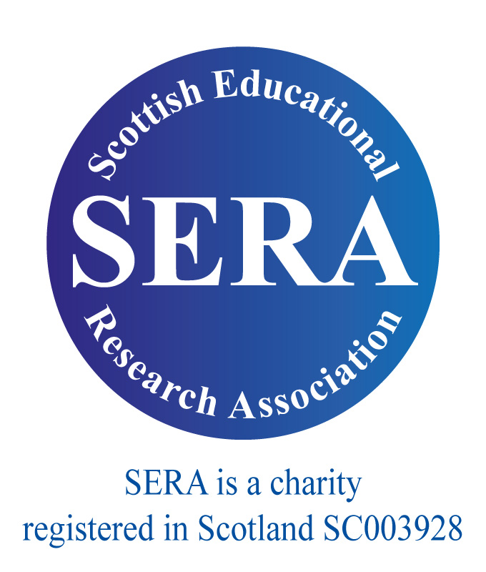 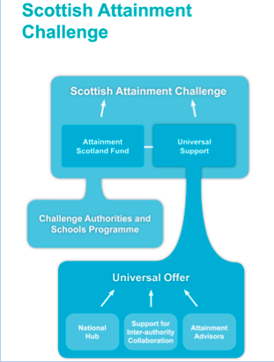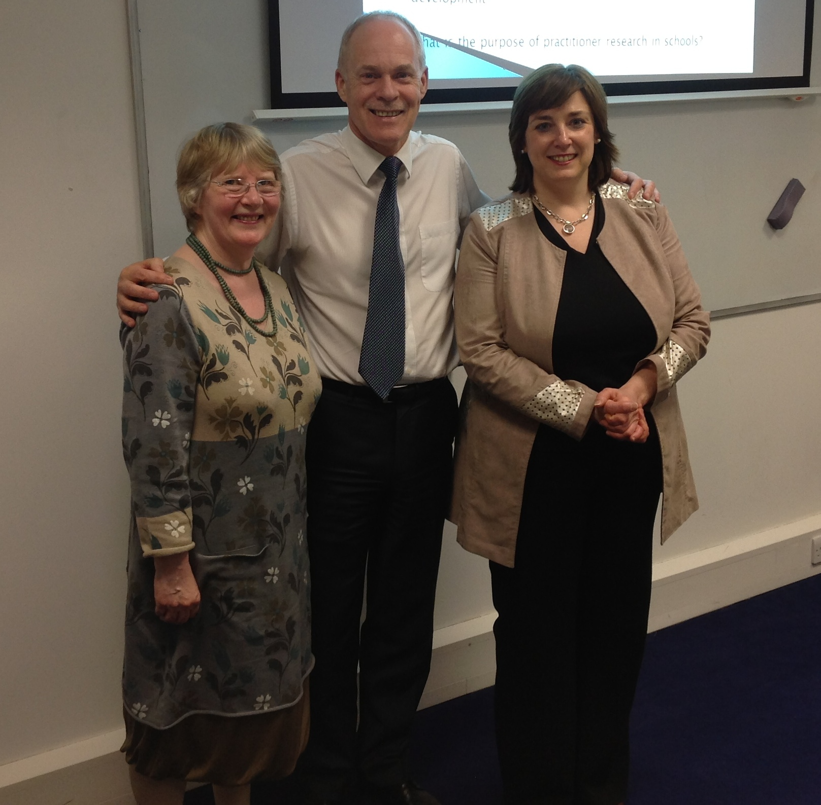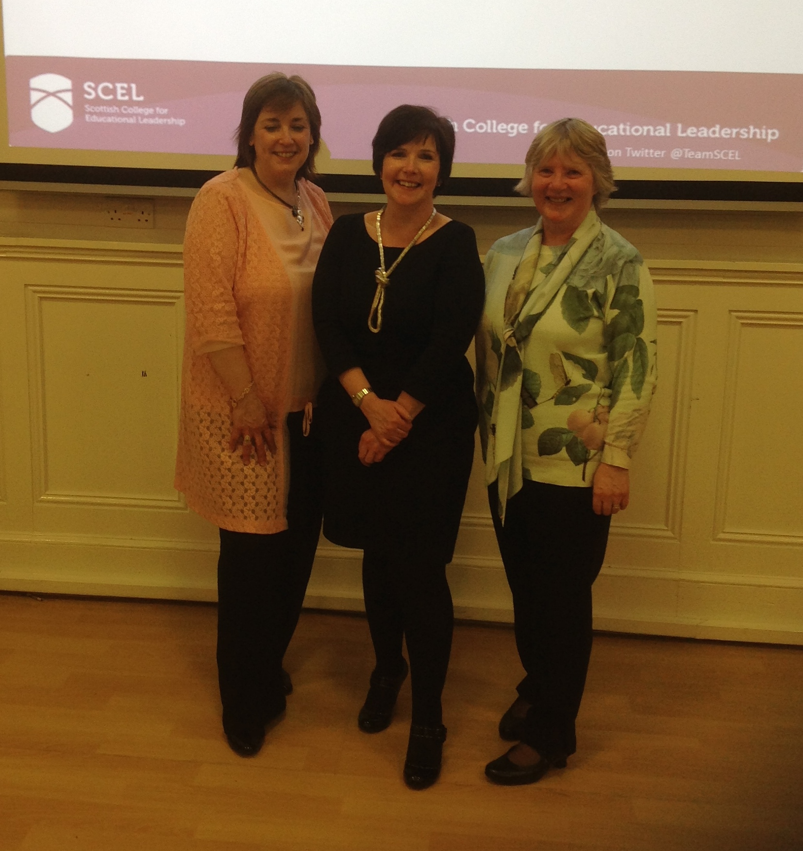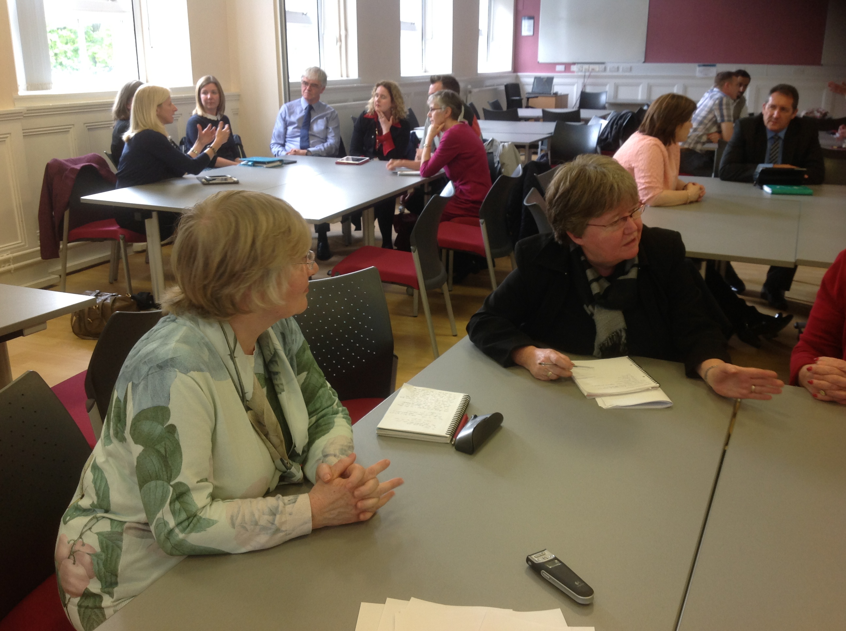

Newsletter 2 (1)

The network is open to both SERA and non-SERA members

Key Questions

**How can the new network influence the current leadership agenda in Scotland and beyond?**

**How can the new network promote research within the field of leadership to inform future understandings of leadership and leadership development within Scotland and beyond?**

Spring 2016

**INSIDE THIS ISSUE**

1. **Key Developments in Scottish Education**
2. **Reports on our initial event in April and formal launch in June**
3. **Planned events for 2016**
4. **Recent & forthcoming events & conference presentations**
5. **Other information and business**

Welcome to the second newsletter of the SERA Leadership in Scottish Education Network [LiSEN]. Dr Margery McMahon and myself (Dr Joan Mowat) are delighted to report that the network has got off to a very strong and positive start, having attracted a very diverse and international membership with over seventy members gained in the short period of time since the network was established in November 2014 – testimony to the need for a network of this kind. What is particularly pleasing is the mix of practitioners (with representation from schools and local authorities); academics (from a range of universities) and policy makers, with the GTCS, Education Scotland and SCEL represented. We have held two very successful events (to follow) and wish to thank Professor Stephen McKinney (responsible for SERA networks) for his very warm support.

# SERA Leadership in Scottish Education Network [LiSEN]

Derived from Education Scotland website

This past year has seen highly significant policy changes in Scottish Education which will have significant implications for leadership. Key amongst these is the National Attainment Challenge and the National Improvement Framework, the latter of which was launched on the 8th of January. The National Attainment Challenge is a highly ambitious agenda which builds upon previous work such as the Child Poverty Strategy and is modelled on the London Challenge. The London Challenge was widely acclaimed to have impacted significantly upon attainment within the city although a range of commentators have forwarded alternative explanations for the success, such as changing demographics (eg. changes in the ethnic population). The Scottish policy was informed by a study undertaken by Sosu and Ellis (2014), commissioned by the Joseph Rowntree Foundation, which indicated that the gap in attainment between children from low- and high socio-economic backgrounds emerges at an early age and widens further as children progress through their schooling, resulting in widely different and statistically significant educational outcomes and destinations for young people. Clearly, addressing a problem of such magnitude requires a focus upon the highest quality leadership at all levels of the system and a systems leadership approach.

The National Improvement Framework draws upon the findings of the OECD report, ‘Improving Schools in Scotland: an OECD perspective’ (Scottish Government, 2015), evaluating ‘Curriculum for Excellence.’

The Scottish College for Educational Leadership has also gone from strength to strength and the Framework for Educational Leadership was launched in 2015. ‘Into Headship’ is now well underway as is the Fellowship programme for experienced headteachers. ‘Middle Leadership’ and ‘Extended Induction’ are in development.

Sosu, E., & Ellis, S. (2014). Closing the Attainment Gap in Scottish Education: Joseph Rowntree Foundation.

# Key Developments in Scottish Education

## April event: University of Strathclyde, Guest Speaker – Ken Muir, CEO GTCS

Ken was invited to address the network on the topic of furthering a research culture in Scottish schools. In particular, to examine the following set of questions which would also be used to prompt discussion after the talk:

* What constitutes a ‘research culture’ – what might it look like?
* How can national bodies and the research community best support teachers to access, communicate and interpret research?
* How do we ensure that educational leadership research is of value and relevance for both policy makers and practitioners?
* How do we best foster collaborative approaches to the development of research into leadership and leadership development?

Ken gave a very thought-provoking and entertaining talk on the challenges to be faced in this quest and drew from his own small-scale enquiry as he visited schools and colleges to ask teachers how they perceived teacher research and how it was encouraged within their establishments. He drew from Hargreaves to observe that the rise in interest in teacher research is aligned with the increasing focus upon ‘evidence-based’ practice or teaching as a research-based profession (in line also with the recommendations of the Donaldson review) but also a response to concerns that academic research impacts little on policy or professional practice.

Ken’s research into teacher research revealed some interesting (but, not surprising) insights: “You’re kidding. I haven’t enough time to do the day job as it is”, ranging from those who thought it was the province of university departments to those who saw it as something integral to what they do: “if you mean experimenting with things in my class, then I do it every day...it’s how I can improve things. I suppose that’s a kind of research, isn’t it?” Three messages/questions to emerge for Ken from this small-scale investigation were:

* Confusion and uncertainty as to what constitutes research
* Teachers being left to try and understand and make sense of the concept of “teachers as researchers”
* Whose role is it to lead (or is it manage?) the promotion of a research culture in schools?

Ken then explored the different ways in which the GTCS supports the development of a research culture in Scottish schools, including the revised professional standards and professional update which foster and encourage engagement with research.

***April event discussion***

The discussion which followed this interesting talk centred around two key themes:

### ***Issues, Challenges and Opportunities***

A significant aspect is the need to create space and time for research, given the multiple demands upon teachers and schools and to recognise that teacher engagement with research is complex and multifaceted – it takes many different forms. Research cannot be seen solely in terms of large-scale studies that are concerned with ‘effect size’, although these play their part. It was suggested that teacher research should inform and drive school improvement plans and local authority priorities, rather than being constrained by them. This has implications for school leadership (and the role which school leaders would play in the process) and for the need for cultural change (leading to structural change). This would require school leaders to be knowledgeable about research and how to engage with it as well as having a commitment towards it.

### ***Accessing and using research***

It was felt that national bodies play an important role in enabling access to and supporting the use of research, such as through the GTCS research engagement group, EducationHub and facilitation of access to research through EBSCO; and through the SCEL fellowship programme. A guide to where to look for/access research ideas and practice in an easily digestible form was suggested as a possible way forward. Universities also have a role to play through funding mechanisms; the generation of knowledge through open access publications and other communication forms, such as academic, peer-reviewed journals and digital and professional publications. However, informal teacher networks, such as Pedagoo and social media, also play an important role. This, however, may raise issues about quality assurance as there is a rigorous review process for formally published research which may not be the case for teacher forums.

It was also considered important to develop knowledge about research through professional learning; developing criticality (informed judgement), research literacy and awareness; and through the explicit referencing of research in public policy documents/texts.

Once again, the importance of leadership emerged as crucial in terms of creating a culture in which research can flourish, requiring space and time for dialogue, not constrained by the boundaries of the School Improvement Plan. This requires ‘buy-in’ from leadership, legitimising engagement with research/enquiry/investigation and acting to facilitate and enable it within the school.

Network Convenors with Ken Muir, CEO GTCS

CEo GTCS

# Key Messages from SERA LiSEN EVENTS

Key Questions

**How can the new network be promoted in Scotland and beyond? – By whom?**

**What other networks/associations/bodies should the network connect with? – What is the potential relationship with SCEL?**

**What are the key themes/issues that the network should engage with in its first year?**

**What vision would you have of the network in five years time? What would it have achieved? With what would it be engaged and with whom?**

**What suggestions do you have for the initial network events?**

Practitioner Enquiry GTCS website

# Key Messages from SERA LiSEN events

SERA LiSEN Convenors with Gillian Hamilton, CEO SCEL

## University of Glasgow, Guest Speaker – Gillian Hamilton, CEO SCEL

We were delighted to invite the newly appointed CEO of the Scottish College for Educational Leadership, Gillian Hamilton, as our keynote speaker at the formal launch of the SERA Leadership in Scottish Education Network (SERA LiSEN) which took place on the 2nd of June at the University of Glasgow. Gillian gave a very interesting presentation which set out the vision and progress of SCEL and the challenges which it faces in supporting a research informed profession. She drew from a range of reports to highlight the critical role which high quality leadership plays in Scottish education and set out the vision of SCEL in aspiring towards this end, highlighting in the process the need to address inequalities within the system. She outlined the scope of work in which SCEL is currently involved from the development of teacher leadership through to the fellowship programme for experienced Headteacher and outlined a range of factors which can facilitate teacher leadership, emphasising a highly collaborative, supportive, enquiry-led approach underpinned by strong leadership within the school.

After outlining current progress and next steps for SCEL, she then posed a set of questions for discussion around the potential role of SERA LiSEN in Scottish education:

* How can the network support the development of a research informed profession?
* How can the network promote research within the field of leadership to inform future understandings of leadership and leadership development within Scotland and beyond?
* How can the network contribute to Scotland’s commitment to raising attainment?

## SERA Network meeting, SERA Conference Nov 2015

The network met at the SERA Conference held in Aberdeen. The purpose of the meeting was to review progress since the inception of the network. It was agreed that the network had been very successful and there clearly was a need for such a network to champion research into leadership within Scottish education and to foster links between researchers, policy makers and practitioners.

## SERA Symposium ‘Raising Attainment: the critical role of Leadership’

Both Dr Joan Mowat and Dr Margery McMahon presented papers at a Leadership symposium at the SERA Conference in Aberdeen.

## SCEL Into Headship Spring Conference

The Scottish College for Educational Leadership recently hosted their Into Headship Spring Conference at the Crowne Plaza in Glasgow. The event was attended by Into Headship programme participants and local authority co-ordinators, as well as some joining remotely via video conferencing.

Drawing on expertise from experienced leaders and head teachers, the programme provided an opportunity to listen to a number of key speakers as well as partake in discussion panels and workshops.

Lena Carter, Depute Head Teacher at Lochgilphead  Joint Campus has been kind enough to blog about her experience of the day. You can read her blog here: <http://www.scelscotland.org.uk/blog/into-headship-spring-conference/>

# Formal launch of Sera LiSEN

Discussions at launch of SERA LiSEN, University of Glasgow