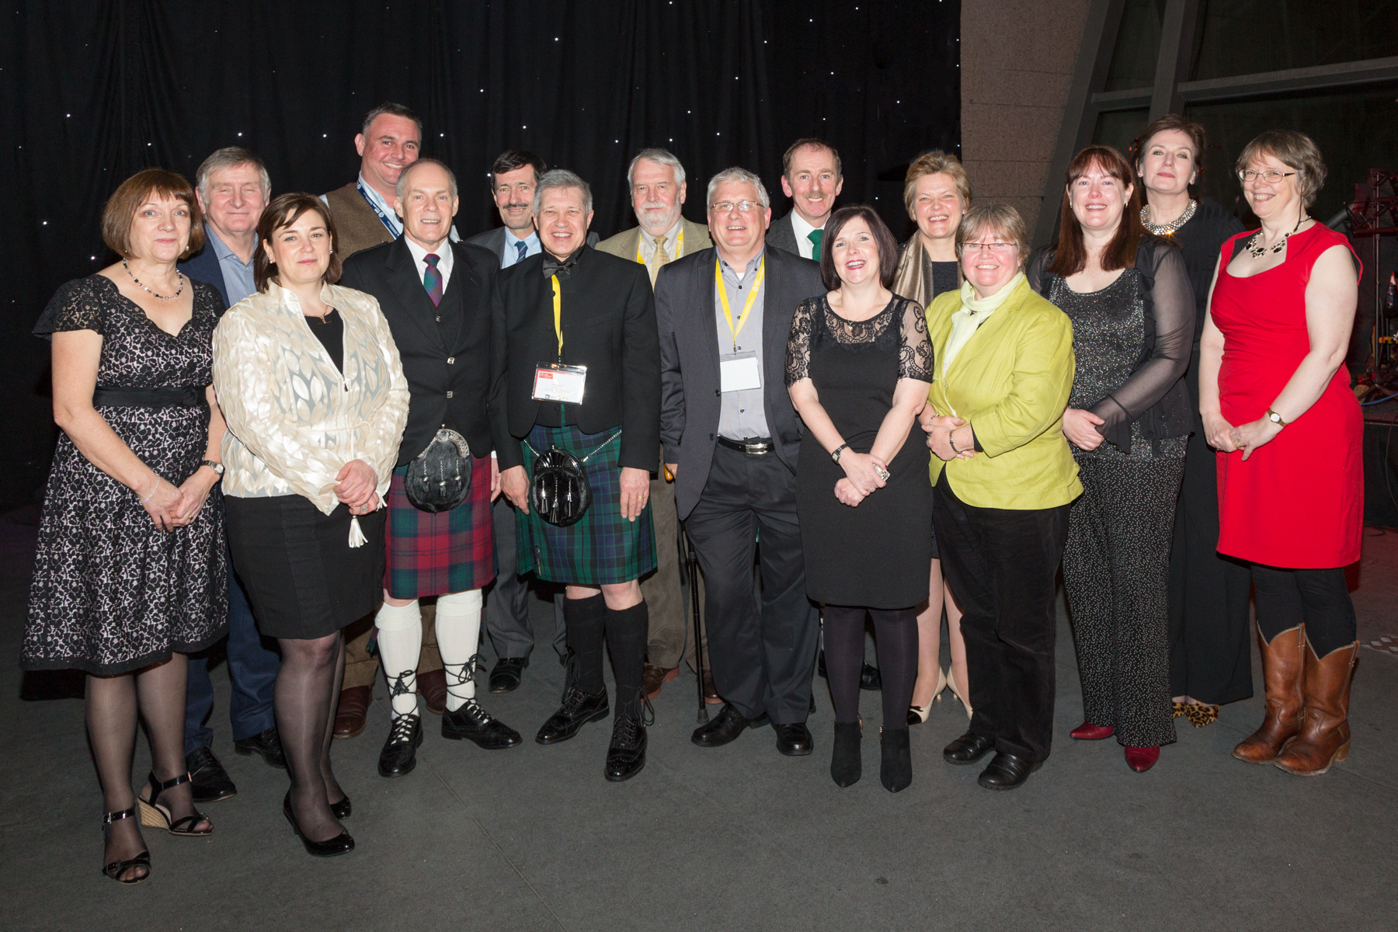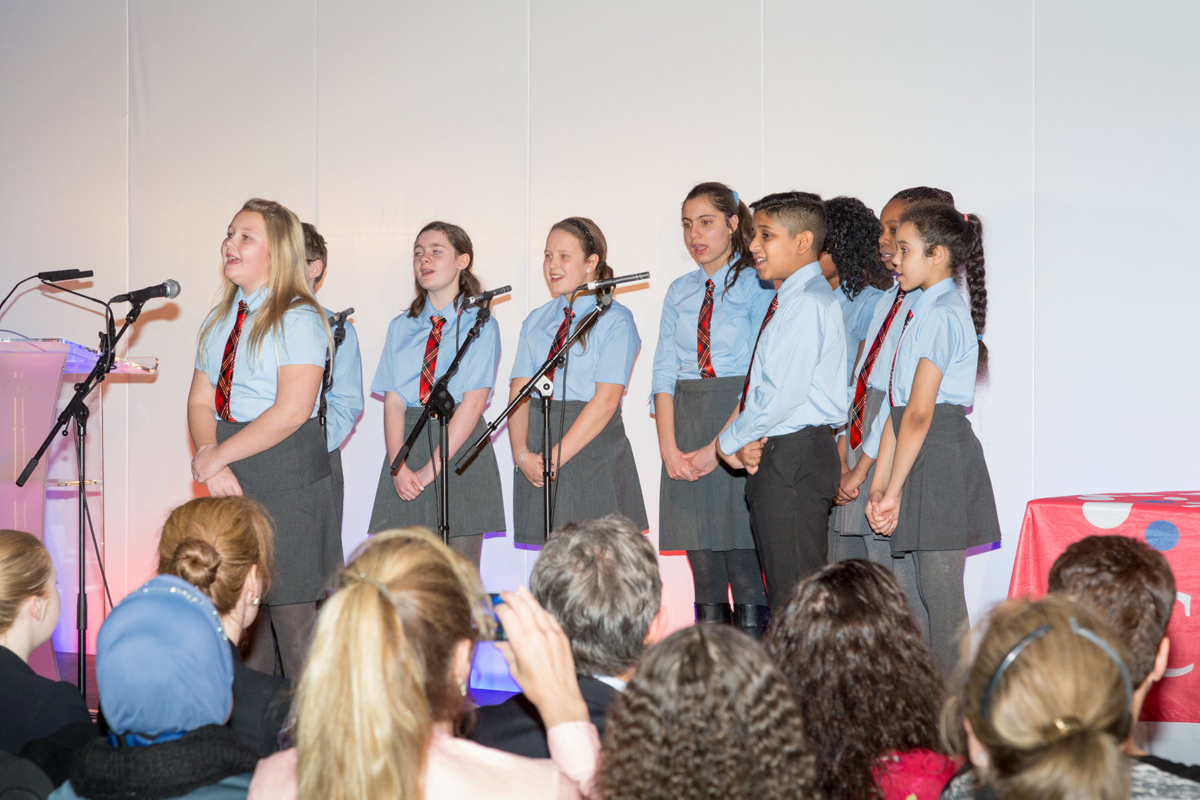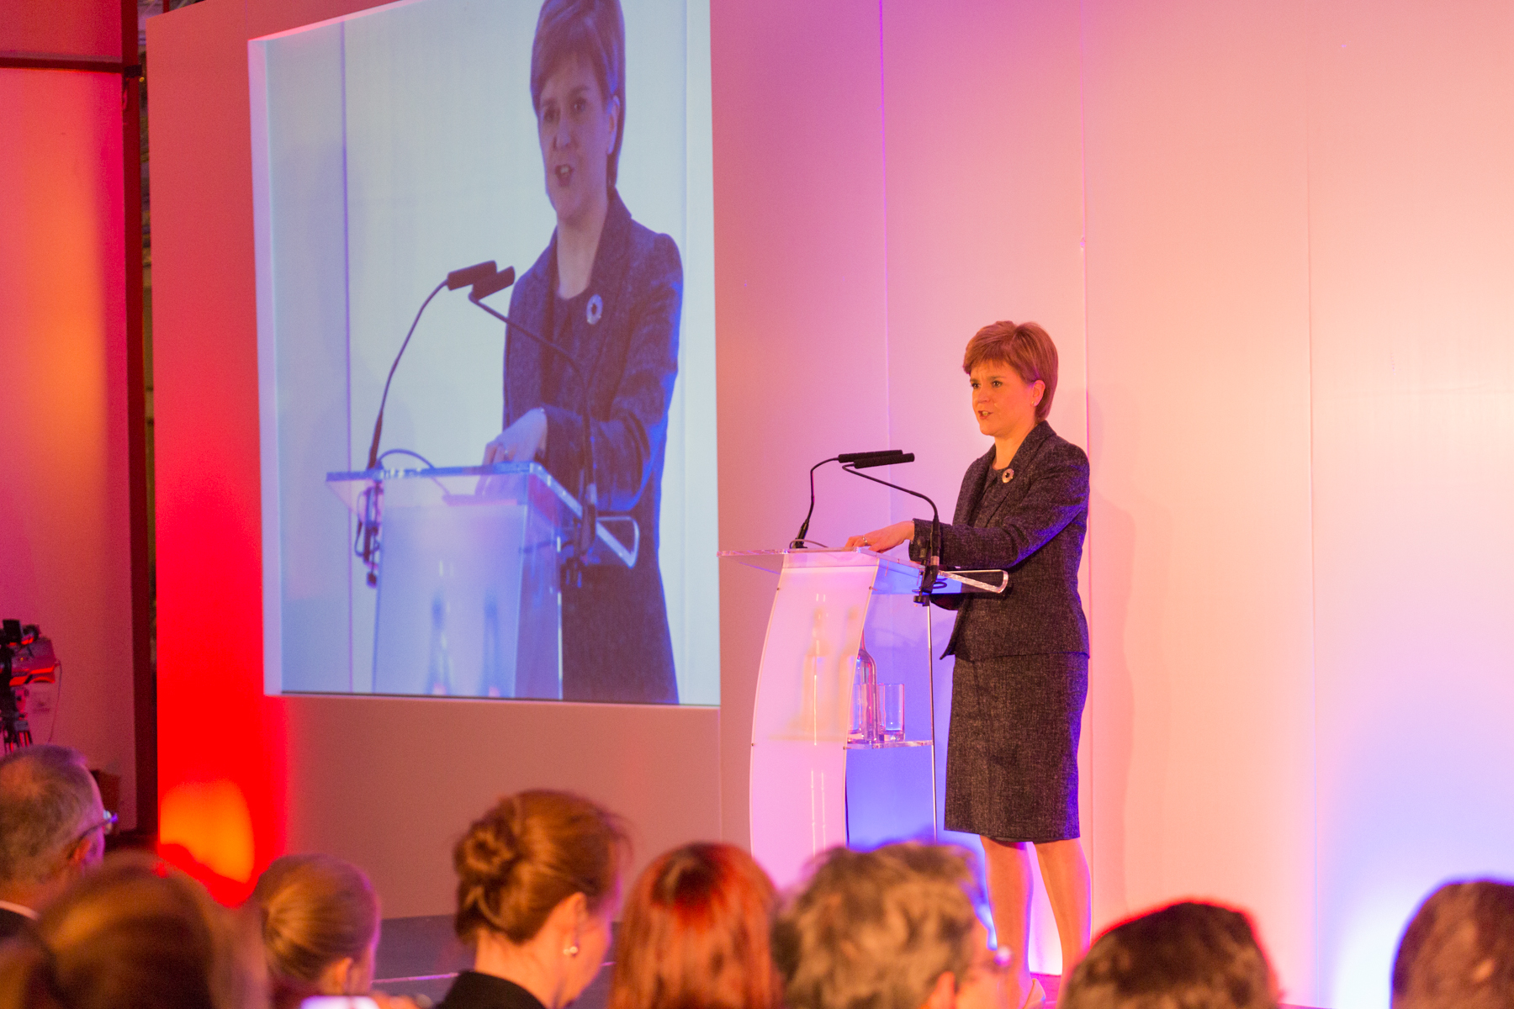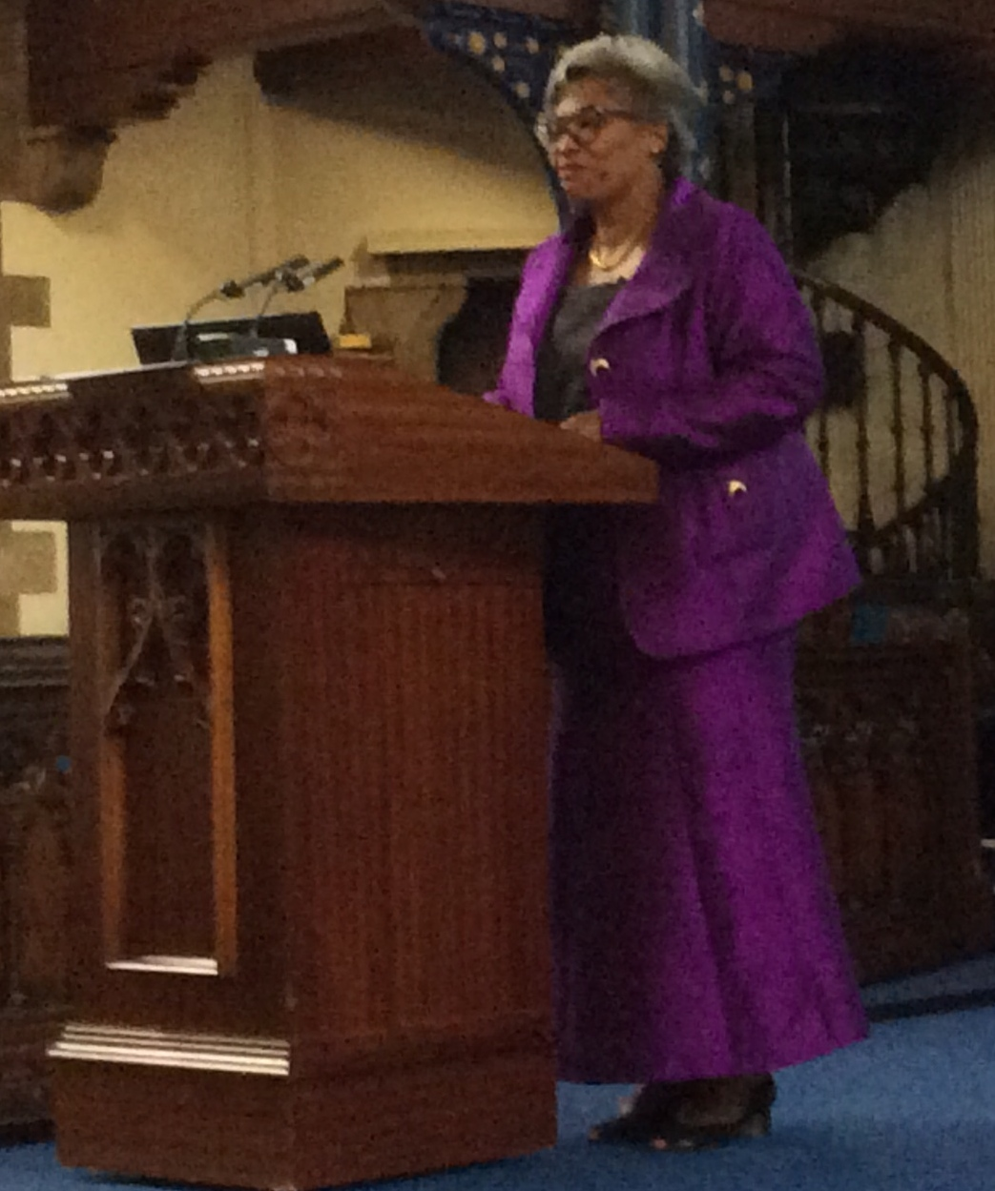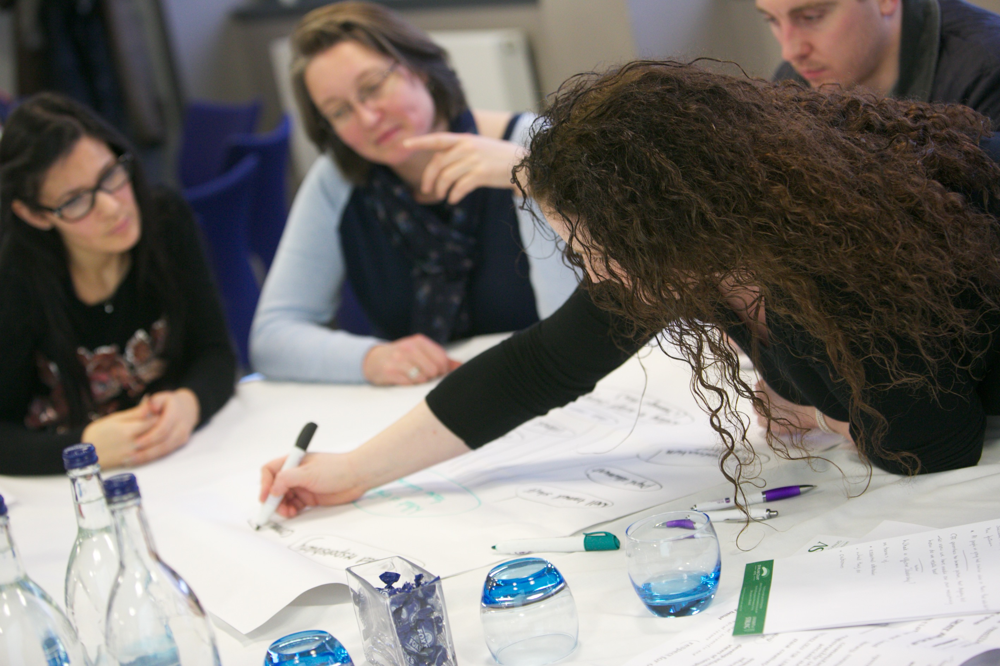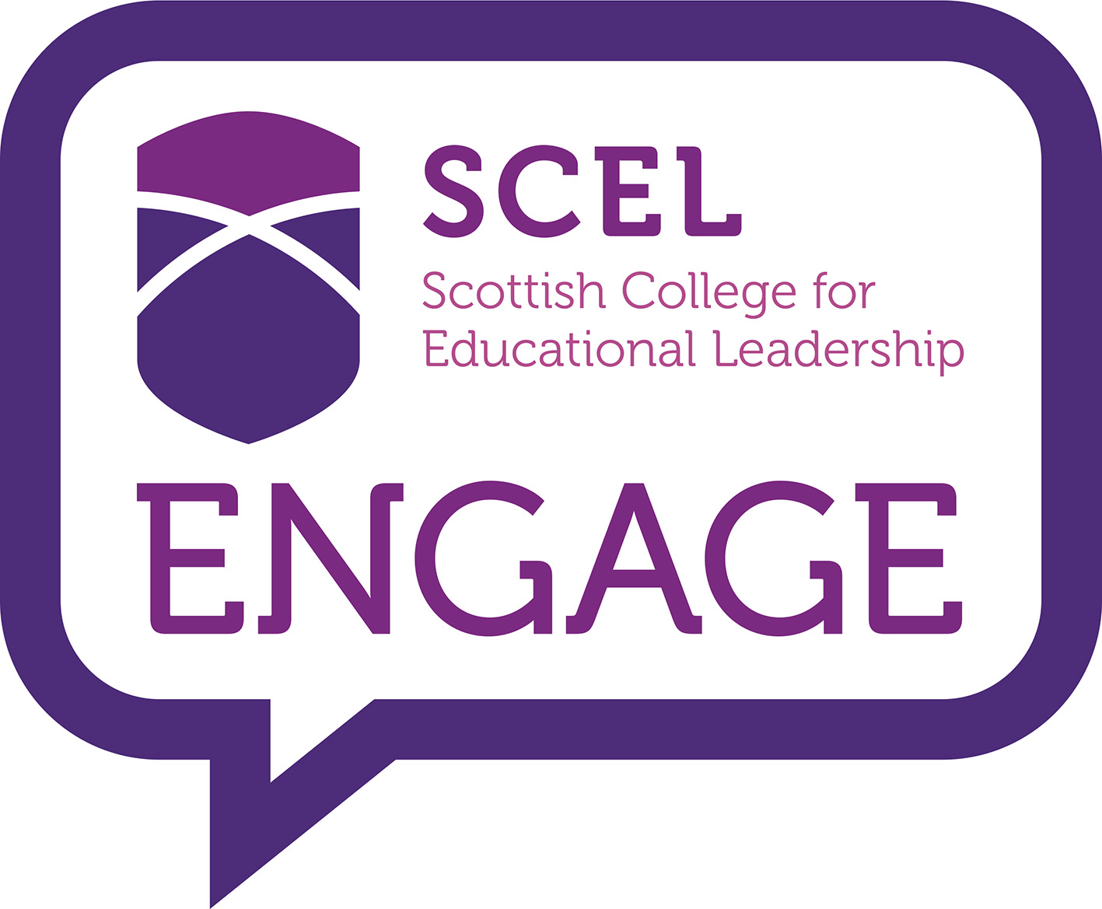

# *“One of the best ICSEIs yet” (Says Emeritus Professor John Macbeath*

# International congress for school effectiveness and improvement 2016

The prestigious International Congress for School Effectiveness and Improvement (ICSEI) conference took place in Glasgow from 6-9 January 2016. With over 600 delegates from almost 80 countries the conference was one of the largest educational gatherings to have been held in Scotland in recent years. The conference was co-chaired by GTC Scotland and University of Glasgow, and organised by a partnership consisting of University of Glasgow, the General Teaching Council, Scotland, Glasgow City Council and Education Scotland. The Times Educational Supplement, Scotland, was the media partner for the conference.

The conference was opened by the Principal of the University of Glasgow, Professor Anton Muscatelli, followed by a policy address and announcement by Scotland's First Minister, Nicola Sturgeon MSP, introducing a new National Improvement Framework for Scottish schools. But at the opening ceremony it was the pupils from Glasgow’s schools who stole the show, singing about their city of Glasgow. A final verse, specially written for the conference, had an important message for conference delegates, ‘when you are talking about school improvement, remember to keep pupils in mind.’

With its theme of *Connecting teachers, schools and systems: creating the conditions for effective learning* the conference offered a unique forum for practitioners, academics, policy makers and researchers to engage through keynote sessions, symposia and individual papers.

All keynote addresses were recorded and are available at <http://www.educationscotland.gov.uk/resources/i/icsei/index.asp>

This is the feedback from the ICSEI Board’ soundings of participants, and perhaps not surprising. Glasgow scored highly on virtually every indicator – the organization, the venue, the hospitality, the catering, the keynote speakers, the breakout sessions, the helpfulness of the volunteer students and the conference receptions and dinners.

While there was a lively (and long) debate about its name and possible change thirty or so years on, as the International Congress it is hard to conceive of a bringing together of people across countries, educational systems and languages. That is ICSEI – dedicated to effectiveness and improvement, across the globe.

Delegates at ICSEI 2016

Musical Entertainment at ICSEI

Nicola Sturgeon, First Minister, presenting at ICSEI

Dr Avis Glaze, Character, Culture and Values Conference, University of Glasgow, June 2015

**Character, culture and values conference, university of Glasgow/SELMAs**

A very animated and interesting round-table discussion, hosted jointly by Character Scotland and SELMAS, led by Aviz Glaze, former superintendent of schools and director of education in Ontario, Canada, took place at the University of Glasgow in June. Avis drew upon Gary Marx’s twenty-one trends for the 21st century to reflect upon the role of leadership in Scottish education. This followed an inspirational presentation by Avis at the Character, Culture and Values Conference, hosted by Character Scotland, at which she reflected upon the place of Character Education in schools and the pivotal role of high quality leadership and adults in modelling pro-social behaviour within the school community.

The quality of schooling in the state of Ontario has been highlighted within a range of OECD reports and Avis shared many of her insights of the challenges she faced in her role as former director of education in building an inclusive, high performing education system which embraced a wide range of stakeholders, including the business community. Avis was the first recipient of the Robert Owen award from the University of Glasgow.

**Addressing the Attainment gap**

SERA LiSEN and SERA Poverty Networks

Tuesday 26th April, 5.30pm – 7.30pm University of Strathclyde, Graham Hills Building (GH510)

We are pleased to announce an event hosted jointly by SERA LiSEN and the SERA poverty network which will focus upon the current imperative to close the attainment gap between children and young people living in poor socio-economic circumstances and those who are more advantaged. We would encourage as many people as possible to come along to participate in this important discussion.

**Graham Donaldson**

SERA LiSEN (May/June)

Date/time to be confirmed.

University of Glasgow

Professor Graham Donaldson, architect of ‘Teaching Scotland’s Future’, will be coming along to talk to members of the network at what should be a very stimulating event, reflecting on developments since the initial publication of the report.

**SERA 41ST ANNUAL CONFERENCE 2016**

School of Education, University of Dundee, Wednesday 23rd-25th Nov, 2016

The SERA Conference 2016 focuses on the pressing issue of attainment and educational improvement. The conference theme welcomes original and critical contributions from scholars and practitioners from a wide range of disciplines and educational settings that explore a rich and diverse view of education and learning as a means for supporting a multiplicity of life-projects, engaging knowledge, relationships and the imagination. This theme is particularly relevant nationally and internationally to individuals and groups who wish to explore the ways in which conceptions of education might move beyond narrowly defined performative measures, but which do so within an era of global testing regimes.

The three-day conference invites researchers and practitioners working in Scottish and international research contexts to share their insights under the theme ‘Challenging? Attainment and improvement.’ Contributions discussing new research possibilities, new forms of contexts for learning, and new types of collaboration among academics and practitioners are welcomed. The deadline for abstracts is *Friday, 18th April*. For further information, please visit the Conference website. <http://www.sera.ac.uk>.

# Forthcoming events

**Annual Children’s Mental Health conference**

*Children’s Mental Health, Well-being and Attainment*

Thursday, 12th May, Hilton Glasgow Grosvenor Hotel

Three children in every classroom have a diagnosable mental health disorder and increasing numbers of children and young people face emotional difficulties which affect their ability to learn and achieve. Schools play a very important role in improving attainment as well as promoting their well-being. The challenge for many schools is how they deal with the growing number of children with mental health problems, how they best support and understand students in need and build a healthy positive environment.

This year’s 2016 Children’s Mental Health Conference will provide practitioners with knowledge, understanding and practical information, so they can best support the well -being and positive mental health of the children and young people in their care and enable them to make progress as well. This conference should be of great valuefor professionals working with and supporting children and young people in education settings. Others with an interest in this area are welcome to attend. To find out more about this event and how to book, please contact <http://www.medicacpd.com>.

**Recruitment for into Headship cohort 2**

Recruitment is now open for cohort 2 of the Into Headship Programme, which will start in June 2016.

The Into Headship qualification is for GTCS registered teachers whose next post is likely to be a head teacher within the next 2-3 years.

Further information - including details on how to apply - are available to download from the Scottish College for Educational Leadership website: <http://www.scelscotland.org.uk/what-we-offer/into-headship/>

Between December 2015 and March 2016, Fearghal Kelly has been carrying out an engagement on teacher leadership across Scotland on behalf of SCEL. This involved using a variety of approaches to support a range of stakeholders to consider the nature of teacher leadership and what is needed for teacher leadership to be developed. He is currently analysing the outcomes from the engagement for a forthcoming report which will be used to inform SCEL's future work on teacher leadership, but you can already access many of the outcomes from engagement sessions on the SCEL Engage website: [http://scelengage.com](http://scelengage.com/).

.

**“This module has given me more knowledge of the issues, policies and factors affecting leadership in schools. As a result, I feel a more confident leader and recognise more accurately the areas in which I need to develop”**

**“I feel that the module has helped me to look at and understand leadership in greater depth. I now base leadership decisions based on sound research.”**

# Forthcoming events & News

# New Publications

**Gillies, D.** (forthcoming). Hannah Arendt, judgement, and school leadership. In: Courtney, S, McGinity, R., & Gunter, H. (Eds.), Educational leadership: Theorising professional practice in neoliberal times. Abingdon: Routledge.

**Gillies, D.** (2015, September). Hannah Arendt, enlarged thought, and school leadership. Paper presented at the conference of the British Educational Research Association, Belfast, UK.

**Mifsud, D. (2016)** The policy discourse of networking and its effects on school autonomy: A Foucauldian interpretation, *Journal of Educational Administration and History,* 48(1), p. 89-112*.*[DOI: 10.1080/00220620.2016.1092427](http://dx.doi.org/10.1080/00220620.2016.1092427). Published online 07 October 2015.

**Article featured on the post of 'Foucault News', 6th December 2015,** [**http://foucaultnews.com/2015/12/06/the-policy-discourse-of-networking-and-its-effect-on-school-autonomy-a-foucauldian-interpretation-2015/**](http://foucaultnews.com/2015/12/06/the-policy-discourse-of-networking-and-its-effect-on-school-autonomy-a-foucauldian-interpretation-2015/)

**Mifsud, D. (2015)** ‘Decentralised’ neoliberalism and/or ‘masked’ re-centralisation? The policy to practice trajectory of Maltese school reform through the lens of neoliberalism and Foucault, *Journal of Education Policy*. DOI: 10.1080/02680939.2015.1121409

**Mifsud, D.** **(2015)** Policy-mandated collegiality in the Maltese education scenario: The experience of the leaders, *Malta Review of Education Research*, 9(2), p. 209-226.

**Mifsud, D.** (2015) Circulating power and in/visibility: layers of educational leadership, *Journal of Workplace Learning*, 27(1), p. 51-67, DOI: 10.1108/JWL-09-2013-0065.

**Article featured on the post of 'Foucault News', 2nd March 2015**, <http://foucaultnews.com/2015/03/02/educational-leadership>.

**Mifsud, D.** (2015) Distributed leadership in a Maltese college: the voices of those among whom leadership is distributed in the college and who narrate themselves as leadership 'distributors', *International Journal of Leadership in Education: Theory and Practice.* DOI:10.1080/13603124.2015.1018335

**Manuscript awarded the 2014 American Education Research Association (AERA) Emerging Scholar Award**.

**Mifsud, D.** (2015) The setting-up of multi-site school collaboratives: The benefits of this organizational reform in terms of networking opportunities and their effects, *Improving Schools*, p. 1-14, DOI: 10.1177/1365480215591253.

**O’Donnell, H.** *Games-Based Learning as an Interdisciplinary Approach to Literacy Across Curriculum for Excellence*, is available from <http://press-start.gla.ac.uk/index.php/press-start/issue/view/2>

**Other News**

Hugh ODonnell informs us that he has

been invited to deliver as an adviser to graduate language students in New Zealand over a week long session of Moodle discussion, Q&A about games, English and Literacy and that his work is also set to feature part of a presentation in Finland at a Schools Science project Edinburgh University are working on.

Hugh’s work on games-based learning was discussed on Inside Learning Technology (May 14th 2012) and is available at: <http://www.insidelearningtechnology.net/?p=219>

and featured in the Times Education Supplement on 15th January 2016 (see below) and featured in a Radio EduTalk on the 22nd of March 2016. <http://www.edutalk.info/listen/>.

Hepburn, H 2016, 'It’s virtually child’s play to improve literacy, says study', The Times Education Suppplement (TESS) 15th January 2016, p. 12.

# Forthcoming presentations

**Mowat, J.G. (2016) *Character Education: An elusive concept – a young person’s journey.* AERA, Washington (DC) April 2016.**

**Mowat, J. G. (2016) *Systems leadership is no leadership at all without a moral compass.* AERA, Washington (DC) April 2016.**

**Mowat, J. G. (2016) *Promoting wellbeing and mental health in children and young people and enhancing their life chances.* Keynote Address. Annual Children’s Mental Health Conference, Glasgow, 12th May.**

**Kirk, D. (2016) *The development of an activist approach to working with boys from socially vulnerable backgrounds in a sport context and the emergence of learning aspirations.* AERA, Washington (DC) April 2016.**

**Kirk, D. (2016) *Physical Education as Edu-Business: Understanding the Impact of Global Networks.* AERA, Washington (DC) April 2016.**

**Joining the Network**

**Membership of the network is open to both SERA and non-SERA members. If you would be interested in joining the network, please contact either Dr Joan Mowat, University of Strathclyde, or Dr Margery McMahon, University of Glasgow, at the following e-mail addresses:**

[**joan.mowat@strath.ac.uk**](mailto:joan.mowat@strath.ac.uk)

[**Margery.McMahon@glasgow.ac.uk**](mailto:Margery.McMahon@glasgow.ac.uk)

**If you would like to join SERA, please go to the** [**SERA website**](http://www.sera.ac.uk/about/map/) **to download the membership form.**

Future Network Events

***Addressing the Attainment Gap***

**University of Strathclyde,GH510 (40 George St, Glasgow)**

**Tuesday, 26th April, 5.30pm – 7.30pm**

**Professor Graham Donaldson**

**University of Glasgow**

**Date/time to be confirmed**