SERA Leadership in Scottish Education Network

Annual Report 2018

The network has gone from strength to strength over the past year and now boasts 155 members drawn from schools, local authorities, the 3rd sector, Education Scotland and the GTCS. We fulfilled our ambition of extending beyond the West of Scotland to host a successful event at the University of Edinburgh bringing together members of SERA LiSEN and the poverty network. Dr Geetha Marcus and Dr Joan Mowat presented on the topic of ‘Closing the Attainment Gap: What can schools do?’ At SERA 2017, a symposium, led by Professor Margery McMahon, drew together insights on the nature of the poverty-related attainment gap (Dr Joan Mowat), distributed leadership (Christine Smith, EdD student, University of Strathclyde) and teacher leadership (Joanna Holmes, EdD student, University of Strathclyde). In addition, two former Into Headship students (Barry Smedley, Douglas Academy) and Alison McCloy (Depute Headteacher, Bearsden Academy) participated within a workshop in which they presented their work through the prism of research. 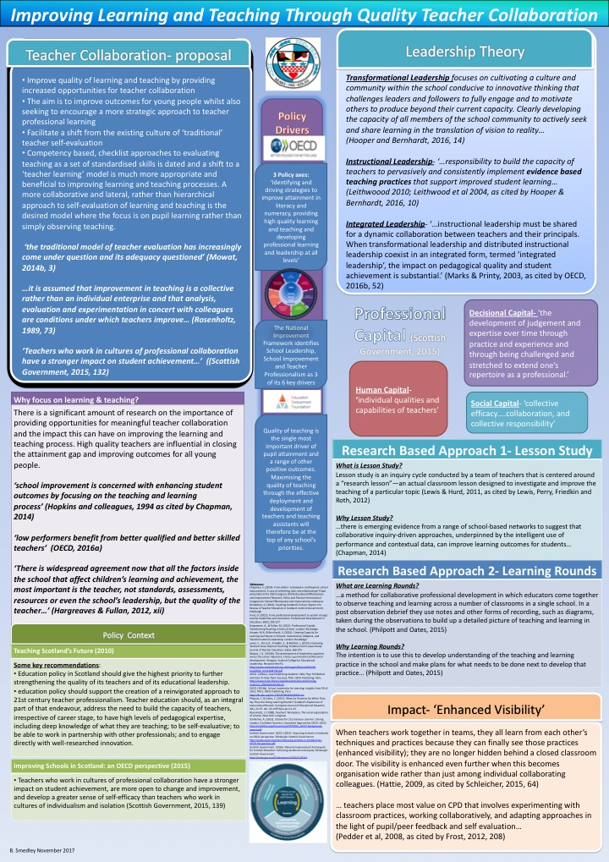
Poster presented at SERA Conference Workshop Nov 2017: Barry Smedley
A further event, jointly hosted by the University of Glasgow, provided an opportunity for members to engage in a dialogue with Professor Toby Greany relating to hierarchy, markets, networks and leadership in England, bringing to the fore interesting contrasts with Scotland. At the forthcoming SERA Conference to be hosted at the University of Glasgow, a roundtable will be chaired by Dr Joan Mowat focussing on middle leadership.

Dr Joan Mowat, SERA LiSEN Co-Convenor
Professor Margery McMahon, SERA LiSEN Co-Convenor

