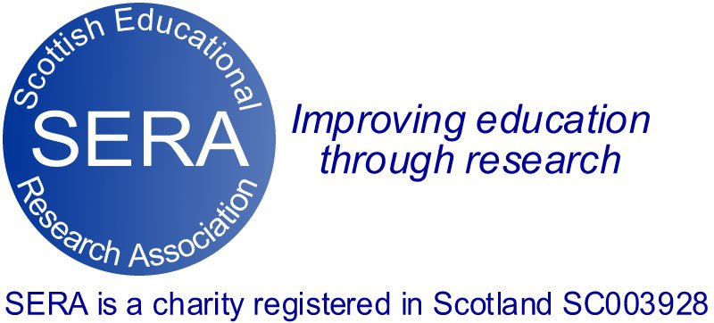

Poverty and Education Network

Highlighting Recent Research into Poverty and Education

Event 1: March 4, 2021 4:00-5:00pm

The SERA Poverty and Education Network Presents two events that highlight some of the current research being conducted by network members on the impact of poverty on education in Scotland. Both events will provide short inputs from four speakers to initiate discussion.

Chair: Stephen McKinney (University of Glasgow)

Speaker 1: Clara Pirie (SPIRU, GCU)
New insights into poverty and education during the Covid times
This presentation summarises key findings from some of the major research reports on poverty and education in Scotland that have been published over the last 12 months

Speaker 2: John McKendrick (SPIRU, GCU)
School food: learning lessons from a crisis
This presentation reports from a survey of Catering Leads from each of Scotland’s 32 local authorities, in which they share experiences of delivering school food at the start of the 20/21 academic year

Speaker 3: Alastair Wilson (University of Strathclyde)
Challenging educational inequality – move the focus from schools to communities?
This session explores the ways in which the attention on schools to solve educational inequality should shift to empowering local communities.

Speaker 4: Stuart Hall and Kevin Lowden (ROC, University of Glasgow)
School collaboration and inquiry to promote equity
This session reflects on an approach to facilitate the use of practitioner inquiry and collaboration within and between schools to tackle poverty-related achievement and related challenges.

Book your place on Eventbrite: https://www.eventbrite.co.uk/e/seraconnects-highlighting-recent-research-into-poverty-and-education-tickets-141300348145?utm_campaign=post_publish&utm_medium=email&utm_source=eventbrite&utm_content=shortLinkNewEmail

