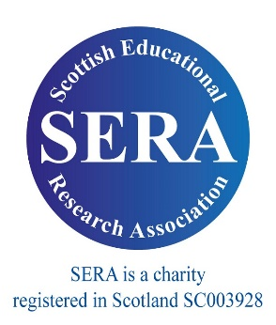

**For more information**: <https://www.sera.ac.uk/estelle-brisard-memorial-prize/>

**Email:** [stella.mouroutsou@stir.ac.uk](mailto:stella.mouroutsou@stir.ac.uk) //**Twitter:** @SERA_Conference

**£250** cash prize and certificate.

Free conference attendance at **SERA 2023!**

Open competition for **best educational research paper** written by an **early career researcher** based in Scotland.

**3000 words only / sole authorship / must not have already been published.**

Deadline for submissions:

**Thursday 31st August, 5pm**

The Estelle Brisard Memorial Prize for Educational Research 2023