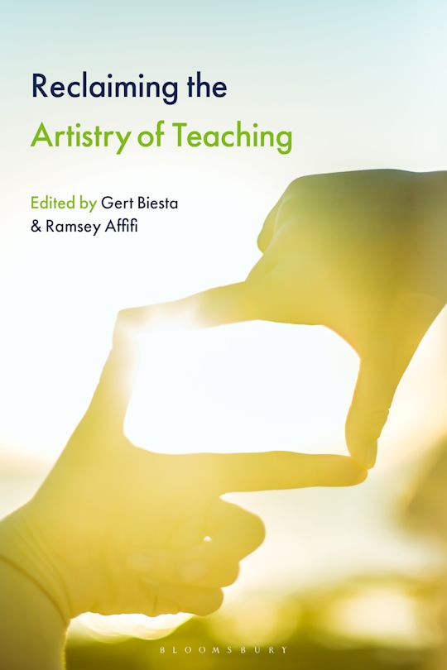
SERA Teacher Education Network seminar
22nd June 2026 3-5pm online
Three authors from the edited book Reclaiming the Artistry of Teaching will share their ideas and encourage discussion.

CHALLENGING SIMPLISTIC STORYLINES: DIVERSITY, COMPLEXITY
COMMONALITIES AND THE ARTISTRY OF TEACHING
Paul McMillan

THE ART AND ARTISTRY OF TEACHING: LOOKING BEYOND THE
QUANTIFIABLE IN INITIAL TEACHER EDUCATION
Lorna Hamilton

AESTHETIC TENSIONS AND SITUATED JUDGEMENTS IN TEACHING
Ramsey Affifi

The book will be published later in 2026.
Microsoft Teams meeting
Join: https://teams.microsoft.com/meet/384289673151764?p=2AlqvIyaFYPJvnc4tz
Meeting ID: 384 289 673 151 764
Passcode: 34YZ35ZD

